**DICE**

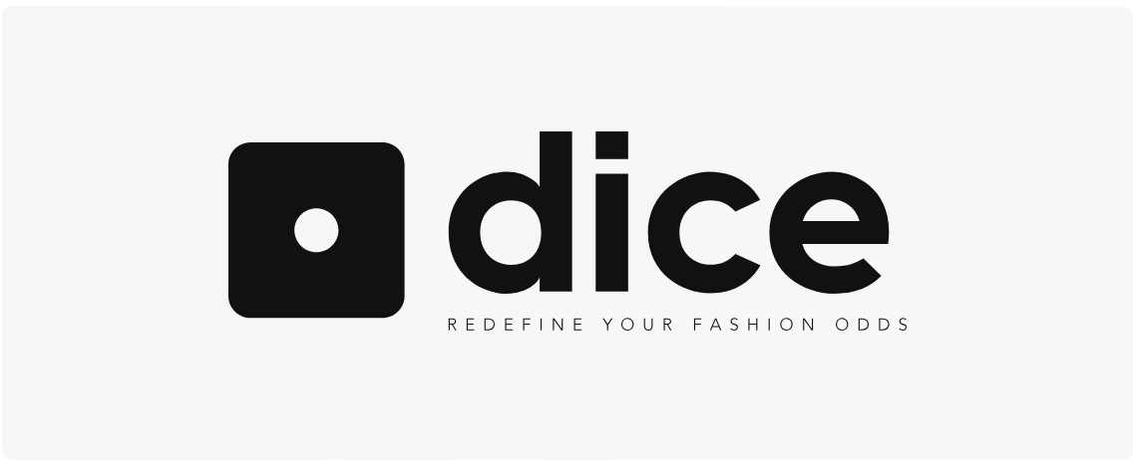

* ROLLTHE DICE AND TAKE A CHANCE ON FASHION WITH OUR CLOTHING BRAND. OUR TRENDY AND VERSATILE STYLES WILL ELEVATE YOUR WARDROBE GAME AND MAKE YOU STAND OUT FROM THE CROWD. WHETHER YOU ARE LOOKING FOR CASUAL WEAR OR SOMETHING MORE FORMAL, WE’VE GOT YOU COVERED, SO WHY WAIT? COME AND JOIN THE FASHION REVOLUTION WITH DICE!!!
* **DICE** is a brand that’s all about taking risk and having fun. Our clothing is design for the bold and adventurous, those who aren’t afraid to stand out and make a statement. With bold colors, eye-catching patterns, and unexpected details our clothes are anything but ordinary. Whether you’re looking to make a splash at the party or just add some excitement to your everyday wardrobe. Dice has got you covered. So go ahead and roll the dice, you never know what you might win.

**SLOGANS**

***Redefine Your Fashion Odds***

|  |  |  |
| --- | --- | --- |
| **MALE** | **FEMALE** | **UNISEX** |
| SHIRTS TROUSERS | SHIRTS SKIRTS TROUSERS | CHECKED |
| BLACK | PINK | CHECKED |
| WHITE | LIGHT BLUE | CHECKED |
| GREY | YELLOW | CHECKED |